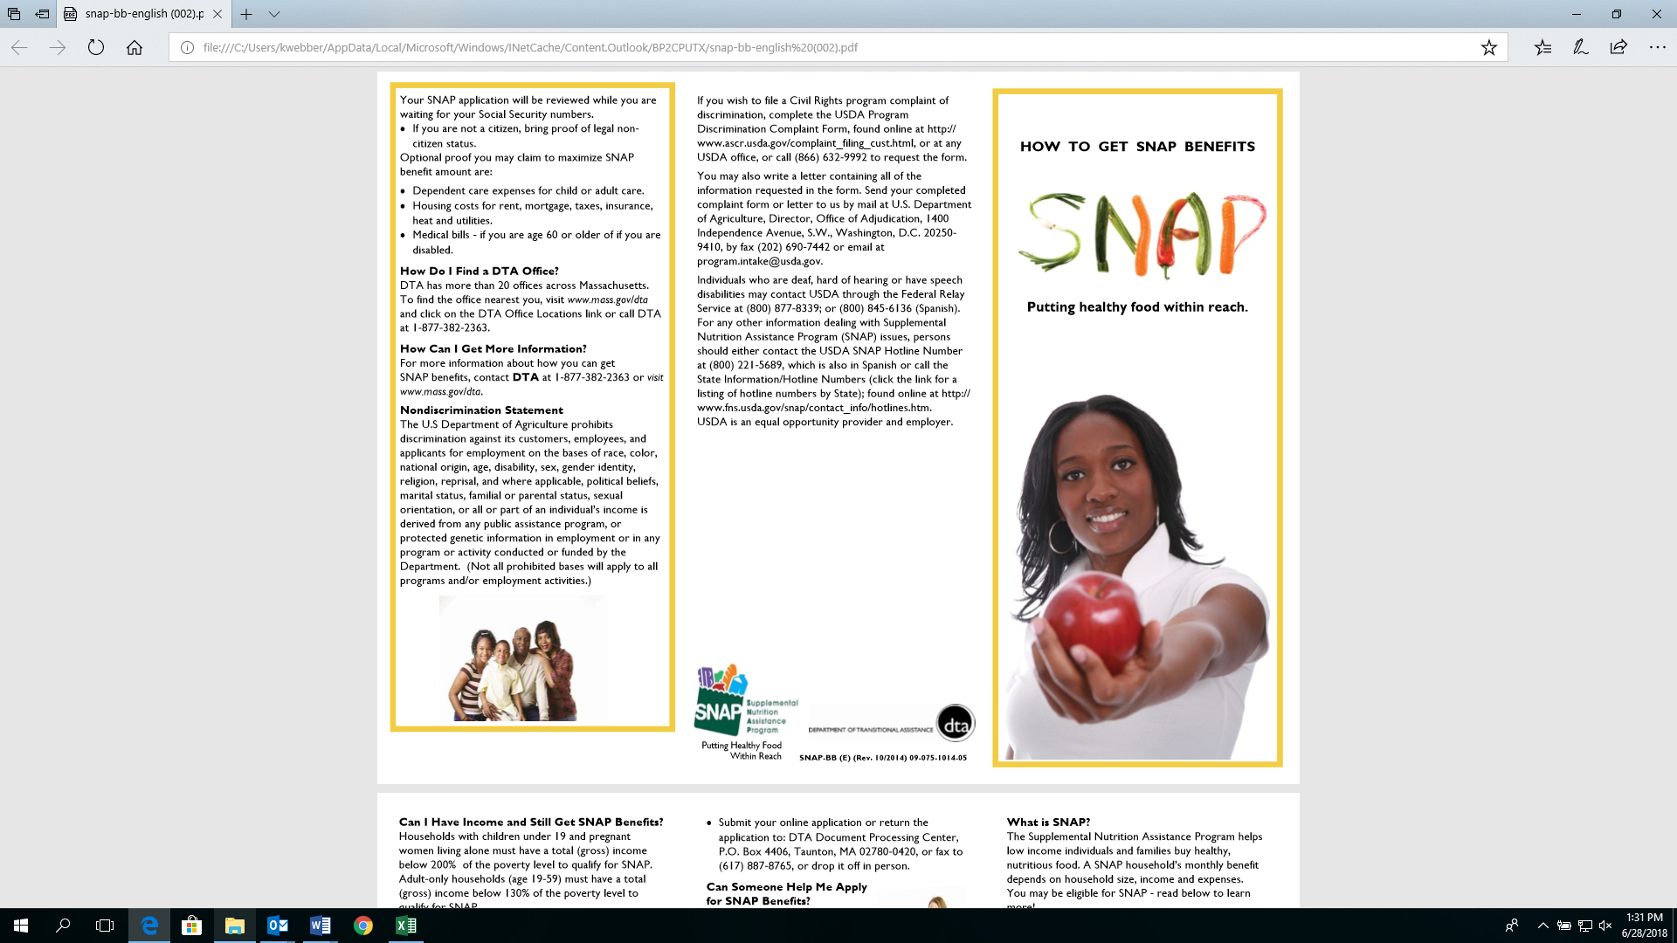

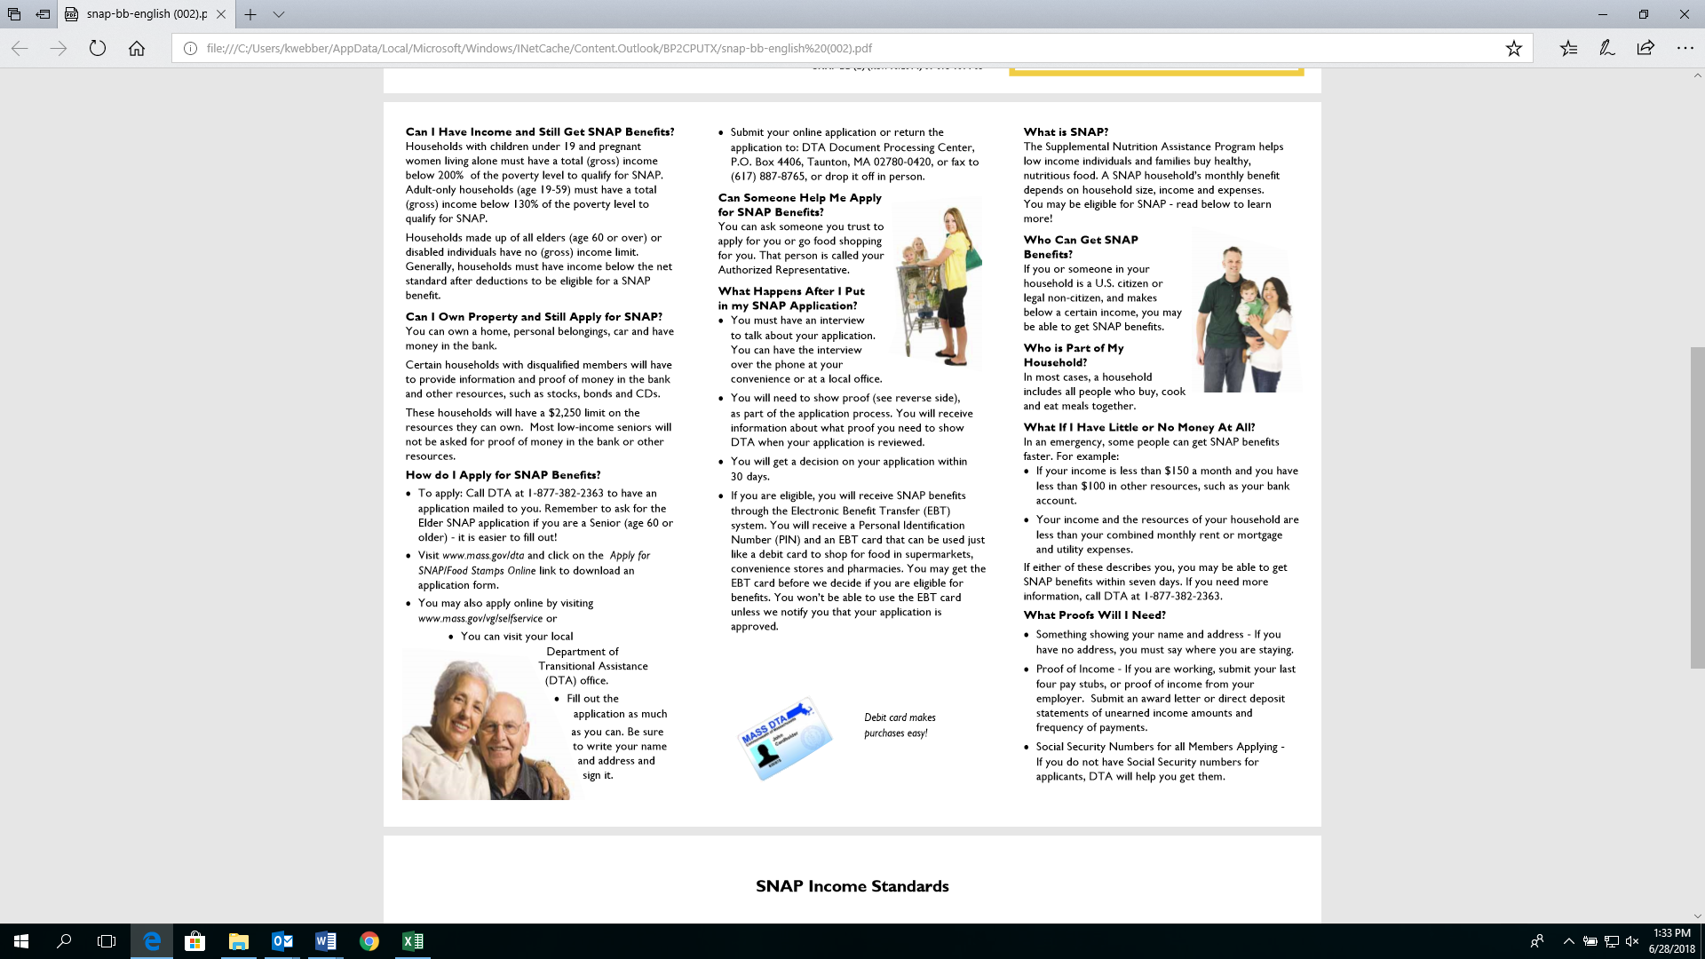

Pictures of little girl jumping rope, doctor with a stethoscope and little boy on a skate board.  Text is explaining in English and Spanish that if your child is eligible for free or reduced school lunch that they may also be Eligible for free or low cost Health Insurance through MassHealth at 
1-800-841-2900.